Fixed vs. Growth Mindsets

Have you ever thought that making a difference is a choice? What are the decisions that can help you make that difference, and the underlying mindsets leading to those decisions? Have certain mindsets the power to create positive change in the world?
Psychologist Carol Dweck is clear about it: individuals with a growth mindset (one related to learning, effort and perseverance) are more likely to take action toward making a difference in their communities. She argues that, by shifting our mindset, we can overcome obstacles, challenge the status quo, and ultimately create a better world.
Below you can find a summary of how people with a fixed and growth mindset respond to several factors such as challenges, adversity, and effort.
Having issues reviewing the graphic below? Access an accessible version of Fixed vs Growth Mindset.
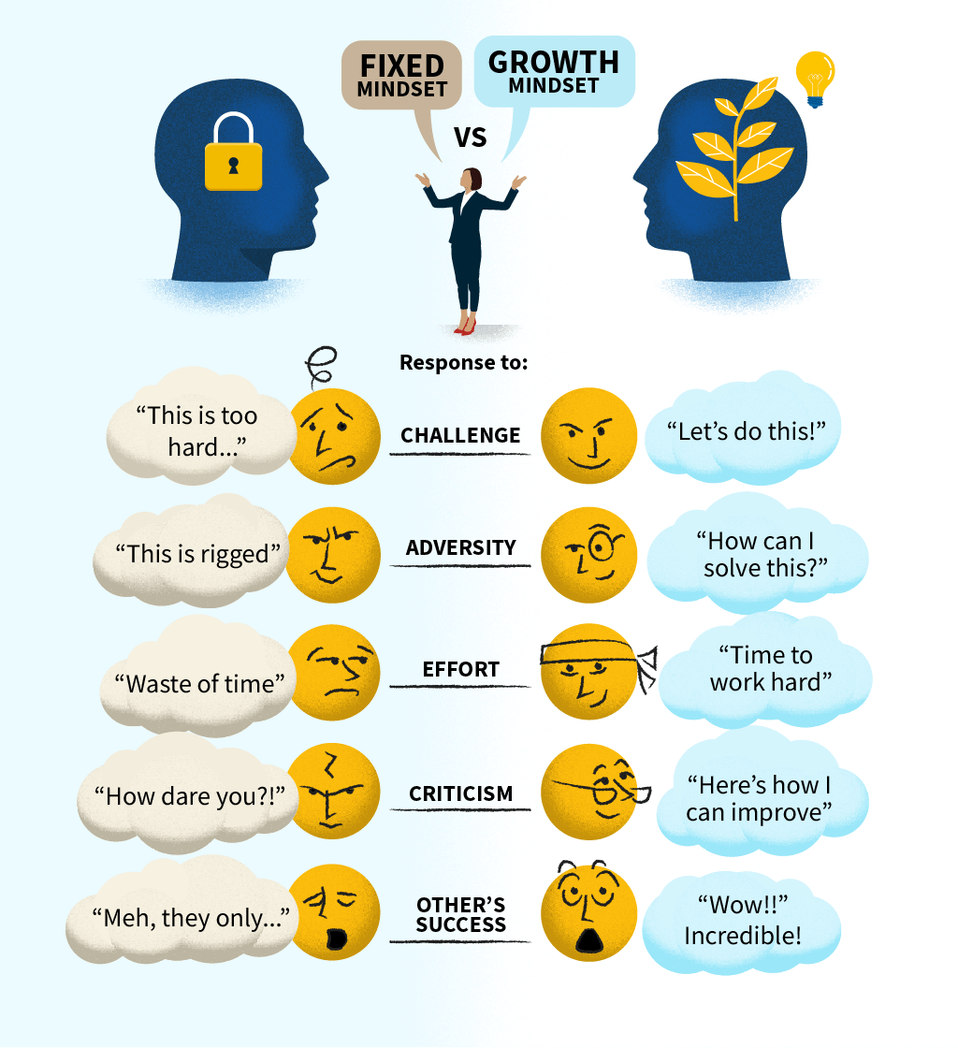
Why Do I Need a Growth Mindset?
Embracing ESG is an ongoing process that requires continuous improvement. Adopting a growth mindset means being open to developing new skills, change, innovation, and the ability to embrace new strategies and practices. These skills are important as ESG often requires creative problem-solving and innovative approaches.
We’ll see some practical examples of fixed versus growth mindsets in the following section.

